Equivalence of Hardware and Software: A Case Study for Solving Polynomial Functions
/* Note: Your Technical Report Title Goes Here */

Author Names(s)
Advisor: Advisor Name
Computer Science and Industrial Technology Department
Southeastern Louisiana University
Hammond, LA 70402 USA

Abstract—
/* Note:
- 100 to 250 words abstract goes here
*/
Newton’s Method for finding roots of polynomials is investigated as a case study in demonstrating the Principle of Equivalence of Hardware and Software. Implementations of this procedure in C++ code and in hardware on a field programmable gate array (FPGA) are presented. The similarities and differences in the two approaches are discussed.
Keywords-
/* Note:
- Three to Five key words here
*/
Newton’s Method; FPGA; Algorithms; Hardware

Introduction
/* Note:
- What is the problem
- Why is it not already solved or other solutions are inferior in one or more important ways
- Why is our solution worth considering and why is it superior in some way
- How the rest of the paper is structured
*/

Computer scientists normally approach the implementation of an algorithm through the use of software. They can readily design programs to accomplish just about any computable task. Conversely, engineers are not as quick to think about software solutions, but tend to approach the implementation of an algorithm through hardware solutions. It is important to note that anything that can be done with software can also be done with hardware, and anything that can be done with hardware can also be done with software. This is called the Principle of Equivalence of Hardware and Software [1]. This research is a case study designed to illustrate this principle, since it is important for advocates of each approach to realize the possibilities associated with the other type of implementation, and to appreciate its benefits.
For applications implemented in hardwired technology, an Application Specific Integrated Circuit (ASIC) is normally built to perform operations in hardware. ASICs are designed to perform specific sets of instructions for accelerating a variety of applications, and thus they are very fast and efficient. The circuits, however, cannot be changed after fabrication. If any parts of the application require modification, the circuits must be redesigned and re-fabricated.
In a software approach, the implementation uses software-programmed microprocessors; these programs execute sets of instructions for performing general purpose computations. This approach is very flexible, since the software instructions can be easily changed to alter the functionality of the system without changing any underlying hardware. A disadvantage of this approach, however, is that this increased flexibility causes a decrease in performance compared to the hardware approach. The processor must read each instruction from memory, decode its meaning, and then execute it, so the performance is significantly less than that of an ASIC.
Reconfigurable computing is intended to fill the gap between hardware and software methods, achieving potentially much higher performance than microprocessors, while maintaining a higher level of flexibility than ASICs. Reconfigurable devices, field programmable gate arrays (FPGAs), contain arrays of computational logic blocks whose functionality is determined through multiple programmable configuration bits. Custom digital circuits are mapped into the reconfigurable hardware to form the necessary circuit. A variety of applications that have been shown to exhibit significant speedups using reconfigurable FPGA hardware include data encryption [2], automatic target recognition [3], error detection [4], string pattern matching [5], Boolean satisfiability [6], data compression [7], and genetic algorithms [8]. FPGAs have also been used as a media player for RealMedia files [9].
This paper presents a particular case study in the field of numerical computation: Newton’s method using Horner’s rule for finding roots of polynomials. The problem is introduced, and both software and hardware approaches are discussed. Full implementations for both of these approaches were developed and are detailed in this paper. Finally, conclusions are presented and issues for future research are discussed.

Related Work
/* Note:
- What other efforts to solve this problem exist and why do they solve it less well than we do
- What other efforts to solve related problems exist which are relevant to our effort, and why are they less good than our solution for this problem
*/

There are many methods for finding the roots, or zeroes, of functions. These are the values where f(x) is, in theory, equal to zero. In reality, because of the finite nature of computers and the limited number of bits of precision, these roots may not equal zero exactly, but can be calculated as being very close to zero. They are within some specified tolerance value, .0000001, for example.
Newton’s method for approximating a root of a specified function f(x) requires that the derivative of the function, f ′(x) be available, and an initial starting approximation x₀ near the desired root must be specified. At this point i successive approximations to the root are found by iterating
x_{i} = x_{i-1} - f(x_{i-1}) / f ′( x_{i-1})
until either f(x_{i}) is within the tolerance or until the difference between x_{i} and x_{i-1} is within the tolerance. When the iteration stops, the most recent approximation to the root x_{i} is accepted as a solution. This method diverges for certain conditions such as “flat” areas of the curve or when given initial values that are far from the actual root.
Horner’s method, a variation of Newton’s method using synthetic division which is based on the remainder theorem and nested representation for polynomials [10], is used. This reduces the number of multiplications, making the implementation more efficient. For an n degree polynomial
f(x) = a_{n}x^{n} + a_{n-1}x^{n-1}+ … + a_{i}x^{i}+ … a₁x¹+ a₀
the number of multiplications is reduced from n * (n+1) / 2 to n, as can be seen from the nested representation of the polynomial
f(x) = (((a_{n}x + a_{n-1}) x + a_{n-2})x + …. + a₁)x + a₀
The number of additions is unchanged. Given a polynomial P(x) where a_{n,} a_{n-1, …,} a_{1,} a₀ are real numbers, the method involves evaluating this polynomial by use of synthetic division at a specific value of x, say x₀. The value of P(x₀) is b₀ after the following sequence of calculations:
b_{n} = a_{n}
b_{n-1} = a_{n-1} + x₀b_{n}
…
b₀ = a₀+ x₀b_{n}
The system must be general enough to allow for user input of a polynomial function and a starting value and to use the method to calculate an approximation to the root. It performs the iterations for Newton’s method to calculate successive root approximations and checks for convergence, as well as possible divergence at each iteration. The solution should then be output to the user.

Implementation
/* Note:
- What we (will do, did): Our Solution
- How our solution works
*/

Software Approach and Implementation
Newton’s Method itself is fairly straightforward to program as a function that computes the f(x_{i-1}) and f ′( x_{i-1}) using synthetic division and plugs these into the formula. The calculations are contained within a control structure such as a while loop that continues iterating until the stopping criteria is met. Before the method can be employed, however, the software must communicate with the user to input the polynomial and the starting value. This can be a bit of a challenge, since the user must know exactly what he is entering—coefficients, exponents, arithmetic signs, etc. The user is instructed to enter the degree of the polynomial and the coefficients, along with their negative signs if there are any. There must be no confusion about what to do for polynomial terms that are absent, for instance, a coefficient of zero.
The algorithm can be programmed with any high level programming language using a function with a loop for the method itself, and functions for user input and validation, and program output. We chose C++, but other languages will work similarly. A one dimensional array, poly[n+1], is the data structure employed to represent the nth-degree polynomial, f(x). In TABLE 1, the index i of the poly array denotes the i-th exponent of the polynomial, and value of poly[i] stores the i-th coefficient of the polynomial.
Parts of the implementation in C++ code are shown in Figure 1, where start_val is initialized by the user. fxRem and dfxRem are the remainder terms for computing f(x) and
f ′ (x), respectively. The loop repeats until difference between x and x_old is less or equal to TOLERANCE, a constant set equal to 0.0000001. Each iteration applies Horner’s method to calculate successive estimates for the root from f(x) and f ′ (x).
- One dimension array, poly[n+1], represents a nth-degree polynomial (a_{n}x^{n} + a_{n-1}x^{n-1}+ … + a_{i}x^{i}+ … a₁x¹+ a₀)
Index (Exponent) | n | n-1 | … | 1 | 0
Value (Coefficient) | a_{n} | a_{n-1} | … | a₁ | a₀

int poly[n+1]; // nth degree of polynomial
float x = start_val;
float fxRem; // f(x) remainder
float dfxRem; // the first derivative f'(x) remainder
while (difference(x, x_old) > TOLERANCE) {
fxRem = 0; dfxRem = 0;
// Calculate fxRem and then dfxRem
for (int i = n; i >= 0; i--) {
fxRem = poly[i] + x * fxRem;
if (i > 0)
dfxRem = fxRem + x * dfxRem;
}
x_old = x;
x = x - (fxRem / dfxRem); // Update x
}

- Software Implementation for Newton Method with Horner Algorithm
Consider, for example, the evaluation of f(x) = x³ + x² -3x -4 for initial estimate x₀ = 2. The remainder value of f(2) is 2 and for f ′(2) is 13 as shown in TABLE II. The new x estimate is 1.8461539. Figure 2 shows the root (x = 1.8311772) of f(x) is found after looping 4 times.
- Remainder Evaluation of f(x) = x³ + x² - 3x – 4 for Initial Estimate x₀ = 2
 | x³ | x² | x¹ | x⁰
x₀ = 2 | 1 | 1 | -3 | -4
 |  | 2 | 6 | 6
 | 1 | 3 | 3 | f(2) = 2
 |  | 2 | 10
 | 1 | 5 | f′ (2) = 13

Programming the solution in software has several advantages. First of all, most computer scientists are usually adept at some programming language, so the software is available and the learning curve for using it is low. The most difficult part of the problem is to understand the algorithm and to communicate expectations to the user. This communication is also an advantage of programming the solution in software. The programmer can display complete instructions for user input specification, validate the input, and communicate further with the user if there are problems. The output is also very flexible since an entire computer screen or user windows are available, and the programmer can design the output in a variety of forms using text or graphic effects as necessary.
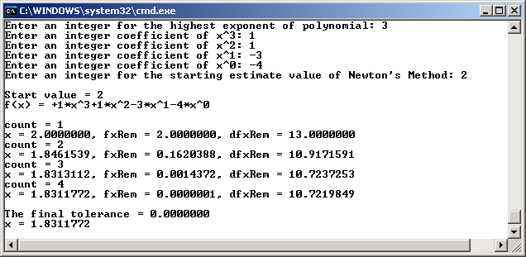

- Software Sample Run (f(x) = x3 + x2 - 3x - 4) to Find the Root (x = 1.8311772

Hardware Approach, Equipment, and Programming
For this research the Altera DE2 package, having a field programmable gate array device that is designed mainly for educational purposes, is used. The Altera’s DE2 packages and FPGA board with multimedia features can be used for many research purposes, but most real world implementations require more extensive, and hence, more expensive, hardware.
The DE2 package includes the hardware board and software. The Cyclone II chip on the DE2 board is reconfigurable and is currently used in many electronic commercial products. The block diagram of the DE2 board is shown in Figure 3. The Cyclone II is a FPGA device with 475 I/O pins. All connections are made through the Cyclone II device, and thus developers can configure the FPGA through the USB blaster to implement any system design. The FPGA will retain this configuration as long as power is applied to the board. The EPCS16 chip provides non-volatile storage of the bit stream, so that the information is retained even when the power supply to the DE2 board is turned off. When the board's power is turned on, the configuration data in the EPCS16 device is automatically loaded into the Cyclone II.
The Altera Quartus II software is comprised of an integrated design environment that includes everything from design entry to device programming. Developers can combine different types of design files in a hierarchical project. The software recognizes schematic capture diagrams and hardware description languages such as VHSIC (Very High Speed Integrated Circuits) Hardware Description Language (VHDL) and Verilog. The Quartus II compiler analyzes and synthesizes the designed files, and then it generates the configuration bit stream for the assigned device. It then downloads the configuration bit stream into the target device via the USB connection. System developers can simulate the designed component, examine the timing issues related to the target device, and modify the I/O pin assignments before the configuration is downloaded onto the chip on the DE2 board. The Quartus II computer-aided design tools work for both the chips on the DE2 and other Altera devices.
Hardware implementation for Newton’s method with Horner’s algorithm is written in VHDL language as shown in Figure 4. A finite machine transfers states in the clock rising edge, and an asynchronized input resets the finite state machine. There are five states: initial_state, cal_fx_state, cal_dfx_state, cal_newx_state, and done_state, designed for this finite state machine. Floating point converters, adders, subtractors, multipliers, and dividers are adopted to do the arithmetic calculations. In initial_state, it converts 4-bit signed integer inputs for start_value and poly array into their 32-bit IEEE 754 single precision floating point representations. The finite state machine transfers from initial_state to cal_fx_state after six clock cycles. In cal_fx_state, it calculates a new fxRem, f(x) remainder, and then transfers to cal_dfx-state after 12 clock cycles (five for multiplication and seven for addition operations). In cal_dfx_state, it calculates a new dfxRem, the first derivative f’(x) remainder, and then transfers to cal_newx_state after another 12 clock cycles (five for multiplication and seven for addition operations). Note that dfxRem needs to wait for a new fxRem in order to do the calculation. In cal_newx_state, the calculation of a new x is finished after 13 clock cycles and then it either returns to cal_fx_state or done_state depending on the difference between new and old x values. Note that a new x calculation must wait for the results of fxRem and dfxRem. In done_state, the state remains unchanged. The first run needs 43 clock cycles, and remaining iterations require only 37 cycles.
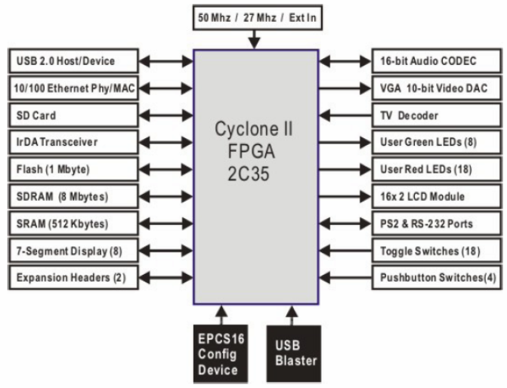

- Block Diagram of the DE2 Board
In Figure 5, the hardware simulation produces the same results as that obtained in software. Input and output nodes are available on hardware simulation after successful compilation, so the system is cleared and ready to accept new inputs for coefficients of x³, x², x¹, and x⁰, and start_value if the asynchronized reset input, 1-bit node, is 1. It starts to calculate and generate the result if the reset is 0. This simulation shows the result node, 32-bit output, starts at 40000000 in hexadecimal or 2.0 in decimal and then remains the same value, 3FEA6404 or 1.8311772 in decimal after 4 iterations, indicating that the solution is found.
Newton’s method is fully implemented and executed on the hardware. After compilation and I/O pin assignments, the hardware configuration is downloaded through a USB port to the Cyclone II FPGA on the DE2 board that runs on a 50MHz system clock. In Figure 6, the user enters a polynomial, sets an initial estimate (start value) for the root of the polynomial, and begins by resetting the system. The user enters the polynomial by selecting either up for 1 or down for 0 on toggle switches. There are four toggle switches for each coefficient, a signed integer range from -8 to 7 or 1000 to 0111 in binary. In this case, the user enters f(x) = +1 * x³ +1 * x² -3 * x¹ -4 * x⁰ by setting 0001 for x3, 0001 for x2, 1101 for x1, and 1100 for x0. The user sets a starting value, 2 (0010 in binary) for polynomial f(x) by pushing either up for 1 or down for 0 on the debounced pushbutton switches. The root (x = 3FEA6404 h or 1.8311772) for polynomial f(x) is found and shown on 7-segment display.
A major limitation of using this implementation was in the lack of easy support for floating point numbers—a necessity for numerical methods. Additionally, the limited number of toggle switches allowed for user input prevents large degree polynomials (many coefficients) and large magnitude coefficients. These problems can be alleviated by using more advanced hardware devices, but for this study the authors chose to work with simpler hardware to demonstrate that good results can be achieved regardless of the system. Another problem with using this particular FPGA device was the limited display for user instruction. Complete instructions in the form of a user manual is required for the user to adequately understand how interact with and use the system.

entity NewtonVhdl is
generic (constant N: integer := 4);
port (
clock: in std_logic;
reset: in std_logic;
poly: in array (N-1 downto 0) of signed (N-1 downto 0);
start_value: in signed (N-1 downto 0);
result: out std_logic_vector(31 downto 0)
);
end entity;
architecture imp of NewtonVhdl is
signal x: std_logic_vector (31 downto 0);
signal poly_sig: array (N-1 downto 0) of std_logic_vector (31 downto 0);
process (reset, clock)
variable fxRem: std_logic_vector (31 downto 0);
variable dfxRem: std_logic_vector (31 downto 0);
begin
if (reset = '1') then …
elsif clock'EVENT and clock = '1' then
case state is
-- poly and start value 4 bits to 32 bits floating point
when initial_state => …
-- fxRem := poly_sig[index]+ x * fxRem
when cal_fx_state => …
-- dfxRem := fxRem + x * dfxRem
when cal_dfx_state =>
-- x := x - fxRem / dfxRem
when cal_newx_state => …
when done_state => state <= done_state;
end case;
end if;
end process;
…
end imp;

- Hardware Implementation for Newton Method with Horner Algorithm
For this problem, the hardware implementation could have been speeded up significantly by hard coding the polynomials into the implementation. We chose, however, to allow for a more robust and user friendly application, one that has greater flexibility. When the user enters the coefficients, those memory locations are not available for work, but if the polynomial is hard coded into the implementation, those locations can be freed up for other uses.
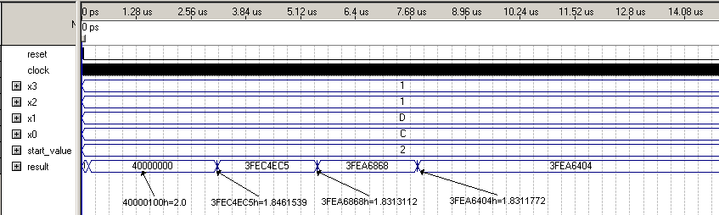

- Hardware Simulation Result (f(x) = x³ + x² - 3x - 4)
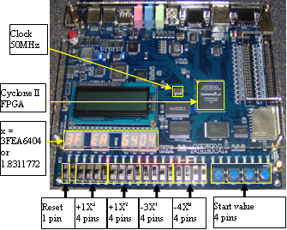

- Hardware Sample Run on the DE2 Board (f(x) = x³ + x² - 3x - 4) to find the root (x = 1.8311772)

Evaluation
/* Note:
- How we tested our solution
- How our solution performed and how this performance compared to that of other solutions
- Why, how, and to what degree our solution is better than other solutions
- Why you should be impressed with our solution to the problem
*/

Conclusion and Future Work
/* Note:
- What is the problem
- What is our solution to the problem
- Why our solution is better
- Why you should be impressed
- What we will do next to:
  - improve our solution
  - apply our solution to harder versions of this problem
  - solve related problems with this solution or a related solution
*/

In this research, the problem of computing a root of a polynomial using Newton’s method with Horner’s rule was presented as a case study for illustrating the Principle of Equivalence of Hardware and Software. C++ was used as the programming language for the software implementation. For the hardware implementation the solution was implemented using the Altera DE2 FPGA device. Both implementations produced the correct results on identical inputs.
The decision of which approach to use is often based on the programmer’s or engineer’s expertise, and normally that will be the approach with which he or she is most comfortable. It is important, however, that one consider the benefits of both approaches. A major goal of this research is to make clear the equivalence of both approaches in terms of their abilities to solve computational problems. Furthermore, although pure software and pure hardware approaches have been discussed in this paper, there exists an entire spectrum of solution approaches involving a combination of the two.
Further research in this area involves the study of other hardware devices and the use of pipelining to reduce the number of clock cycles required for computation. The authors are also investigating issues arising in the implementation of other types of numerical methods such as those involving matrix operations.

References

/* Note:
- 10 or more ACM or IEEE references Here
http://www.southeastern.edu/library/databases/computer/index.html

*/

- L. Null and J. Lobur, “The Essentials of Computer Organization and Architecture,” Second Edition, Jones and Barlett Publishers, 2006.
- A. Elbirt and C. Paar, “An FPGA Implementation and Performance Evaluation of the Serpent Block Cipher,” ACM/SIGDA International Symposium on FPGAs, 2000, pp. 33-40.
- M. Rencher and B. Hutchings, “Automated Target Recognition on SPLASH2,” IEEE Symposium on Field-Programmable Custom Computing Machines, 1997, pp. 192-200.
- L. Atieno, J. Allen, D. Goeckel, and R. Tessier, “An Adaptive Reed-Solomon Errors-and-Erasures Decoder,” Proceedings of the 2006 ACM/SIGDA 14th international symposium on Field programmable gate arrays, Monterey, California, 2006, pp. 150-158.
- M. Weinhardt and W. Luk, “Pipeline Vectorization for Reconfigurable Systems,” IEEE Symposium on Field-Programmable Custom Computing Machines, 1999, pp. 52-62.
- P. Zhong, M. Martinosi, P. Ashar, and S. Malik, “Accelerating Boolean Satisfiability with Configurable Hardware,” IEEE Symposium on Field-Programmable Custom Computing Machines, 1998, pp. 186-195.
- W. Huang, N. Saxena, and E. Mccluskey, “A Reliable LZ Data Compressor on Reconfigurable Coprocessors,” IEEE Symposium on Field-Programmable Custom Computing Machines, 2000, pp. 249-258.
- P. Graham and B. Nelson, “Genetic Algorithms in Software and in Hardware—A Performance Analysis of Workstations and Custom Computing Machine Implementations,” IEEE Sym. on FPGAs for Custom Computing Machines, 1996, pp. 216-225.
- K. Yang and T. Beaubouef, “A Field Programmable Gate Array Media Player for RealMedia Files,” Consortium for Computing Sciences in Colleges, Corpus Christi, TX, April 18-19, 2008, pp. 133 - 139.
- C. Gerard and P. Wheatley, “Applied Numerical Analysis,” 6th edition, Addison-Wesley Publishers, 1999.

BIOGRAPHY

 Jo Smith has attended Southeastern since the fall of 2015 and plans to graduate with a degree in Computer Science in 2018, and then to pursue graduate studies in computer science at MIT. For two summers Jo has held internships with the Naval Research Lab at Stennis Space Center, Mississippi. When not studying computer science, Jo enjoys working on cars and horseback riding with his family in his hometown of Smithville, Texas.

